**P1 - How organisations use information**

**Types of information**

There are two main types of data, and the rest fall under these two categories.

First, there is **quantitive**data. This is data that is factual, obtained through well-defined processes, and is usually numerical.

There is also qualitive data. This is data that is primarily opinion-based, subjective, and may be vague or have no exact value.

This data can also be:

**Primary data**primary data is data that an individual collects themselves, first-hand. This can be through experiments, surveys or observation & recording they have done themselves.

**Secondary data**  
Secondary data is research – data collected from external sources such as the internet, books, articles and documentaries.

Secondary data is less favourable because it may be incorrect or biased, and cannot be checked because you cannot confirm it was collected properly.

**Purpose of information**

Organisations and businesses use data all the time, for a variety of purposes.

**Operational support**Data can be used to support decisions in real-time. Examples of this include managing stock, delivery times or logistics. It is necessary to know some things – such as when new stock is needed or if a delivery is on schedule – in order to complete operations.

**Analysis**Analysis is similar to operational support, except it is used to improve performance. By knowing lots of things about a business, it becomes possible to spot trends and patterns which may be harmful or beneficial. This new data can be used to make decisions about how to improve the business.

**Decision making**When a problem arises, data can be used to make an informed decision on how to resolve the issue. Usually, this involves finding the most cost-effective solution. For example, if a time-sensitive delivery company has delayed delivery, by knowing where the delivery is, where it’s going, what deliveries are after it, whether any other delivery vehicles are nearby and what caused the delay, they can work out how late the delivery is likely to be, whether there is anything the driver can do, if someone else in the area can take the delivery, how this will impact future deliveries, and they may gain some insights into how to reduce the chance of it happening again.

**Gaining advantage**  
Businesses have one purpose – increase profit. Therefore, it is important they are able to take advantage of any opportunities that arise. Spotting trends and patterns helps with management, advertising and logistics – if a business knows that an event is happening ahead of time, they can decide whether to advertise more or stay open longer, etc.

**Internal and external information**

Departments create information which is of use to other departments, and helps different departments collaborate.

Examples of internal information include Finance, Manufacturing, Marketing, HR and Purchasing. By virtue of having information from other departments, they are communicating better. This helps each department make decisions.

External information is data from outside the business, such as commercially available databases and information from the government and researchers, as well as in formation in the public domain, such as the majority of the internet.

**Business functional areas**

Information can be very useful for a business to see how it is performing. They can use the following areas of information to judge their success and improve:

**Sales**The sales department is interested in what products they have sold, to whom and for how much. Sales analyses are very useful to the sales department. They can look at data on:

* Products and their groups (types of product)
* Store/outlet by groupings, geography, store size and organisation history
* Salesperson (for bonuses)
* Customer and customer type

This data can be organised by time and date, so it can be compared to information from other dates or times.

**Purchasing**The purchases department (which purchases resources for an organisation) will mainly use information about suppliers and retailers. They would analyse them by price, by lead-time, by fewest problems and by product availability. The best supplier would have the cheapest prices, deliver quickly and reliably, not give problems with product quality or paperwork and always have the products needed available.

**Manufacturing**The manufacturing department shows how efficient the business is. They analyse how well they use their staff and machinery, the quality of their products and how successful they are, how to minimise wasted resources, and how to react to supply and demand.

**Marketing**  
The marketing department analyses the customers and the organisations competitors. They look at information on sales and organise customers into groups, by age, location, wealth and interests. Most of this information can be gathered from loyalty cards.

**Finance**The finance group is split into two parts – financial accounting and financial management.  
Accounting tracks income and expenditure, while management decides how to spend the income. The management department allocates budgets and authorises large purchases.

**HR**  
The human resources/personnel department analyses information about employees, such as staff turnover, wages, days off/sick days and hours worked. This is necessary to comply with labour laws and employment contracts.

**Administration**Administration tracks and manages the flow of information within an organisation, helping with inter-department communication and reporting.

**M1 – Information flow**

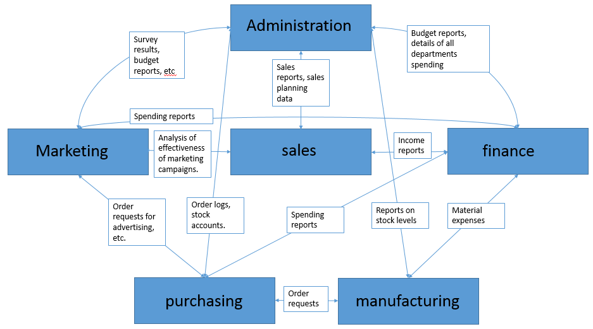

This diagram shows how information flows between the different departments of an organisation. Some departments will communicate very rarely, such as manufacturing and marketing, but some will communicate constantly, such as marketing and finance.